Developers Diary.

Name: Mason Ness
Student Number: 22211800

Questions:
- What you were trying to do, in a sentence.
- The prompt or question you gave the AI, and what it returned, shown as a screenshot or a short quote.
- What you did with it: what you kept, what you changed, and why.
- Anything you rejected or corrected, and your reasoning.

6 step method:
- Understand the problem
- Work through examples
- Break it down
- Plan the approach (Pseudocode)
- Code the solution
- Test & verify

__________________________________________________________________________

A conversational assistant with a finance persona (R1)

6 step method
- Understand the problem
R1 needs a conversational assistant that uses a real language model to answer finance questions, with a clear persona and purpose. It will also handle off topic questions (not related to finance), sensibly by answering them while gently steering back to finance topics, without crashing.
- Work through examples
I thought, what popular in context questions I would ask “am I keeping to budget?” or “what’s my daily budget?”. Off topic questions I would ask “how’s the weather?” making sure the persona would respond responsibly.
- Break it down
The feature splits into three parts; a persona message, chat session, and a question handling function.
- Plan the approach (Pseudocode)
SET persona_setup
    - Who is persona (travel budget buddy)
    - User situation/context (Indo, 2 months, $10,000 budget)
    - Past struggle (Europe)
    - Instruct always to use real data, not generic advice
CREATE chat session using model
SEND persona_setup to chat

LOOP inside run_app
If user chooses “Ask question”
ASK user “type question”
CALL ask_with_data (chat, question,….)
    - Build message containing real data + the question
    - Send conbinded message
    - Returns model reply text
DISPLAY reply
END IF
END Loop
- Code the solution
(See code)
- Test & verify
I tested by asking the persona on topic and off topic questions to see how it would respond. The persona stayed in character while answering my ‘on’ topics as well as my off topic questions or would gently push me back to asking finance topic questions.

Oct 7 (have been suffering a 503 unavailable error) 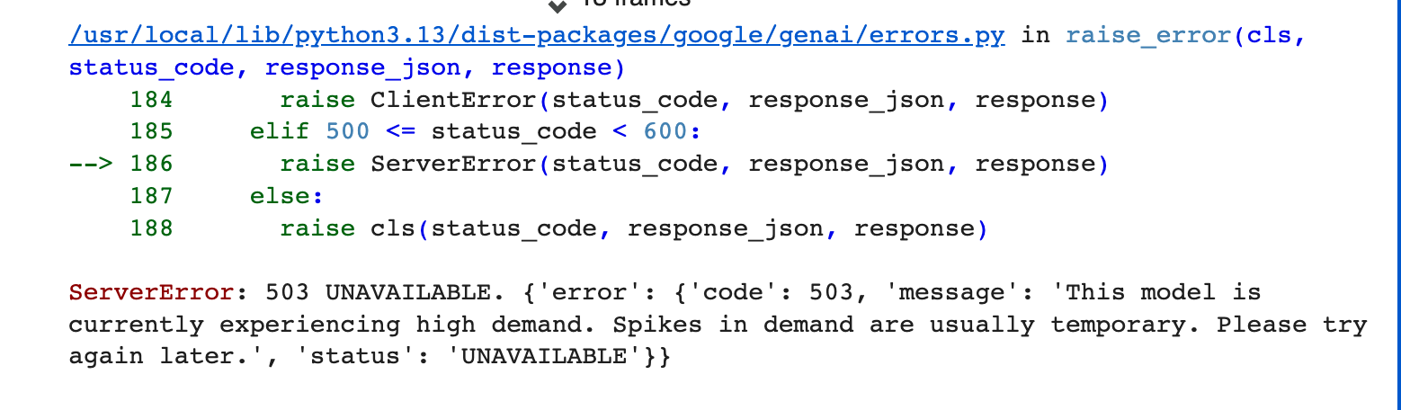

Trying to do R1, Gemini API I found hard at the start.
Found constant errors with my code as this is something new to me. For R1 I had trouble with my API. I understood how it worked, however having a 503 error slowed things down, and it constantly failing made it hard to understand what my errors were and to find a viable solution.

- What you were trying to do, in a sentence.

Trying to complete R1, adding a custom finance (travel assistant buddy) assistant that has a genuine language model when its reply’s, even if question is off topic.

- The prompt or question you gave the AI, and what it returned, shown as a screenshot or a short quote.

prompt = f"""
You are a supportive but strict travel buddy.

The user is on a 2 month moped surf trip through Indonesia. On their last trip (8 Months in Europe) they struggled to keep to their budget and had to go into their savings and find work.

Current trip Budget excluding flights and moped is $10,000

Give them a short, encouraging but honest response about their spending pace, give a day-to-day budget, food, drinks, fuel and miscellaneous.
"""

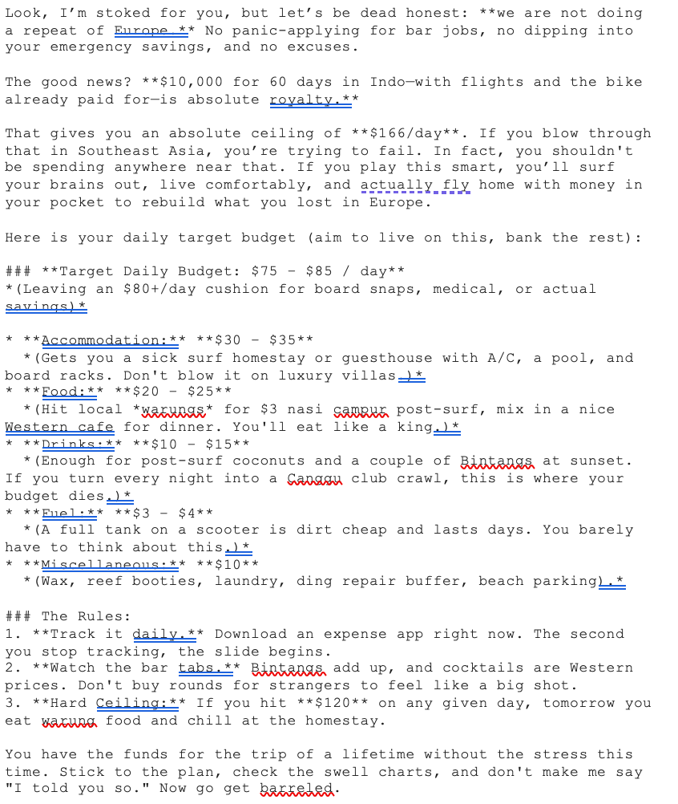

This was the first time I didn’t have a question bar and wasn’t interactive after edits. I was happier with what I got back (see below).
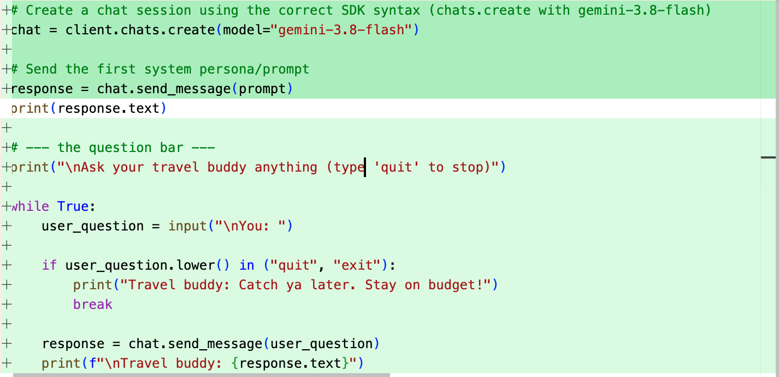

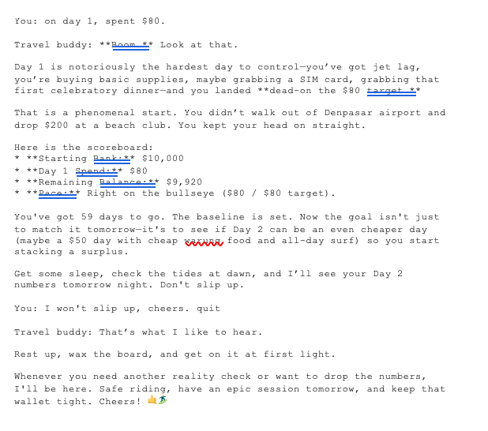
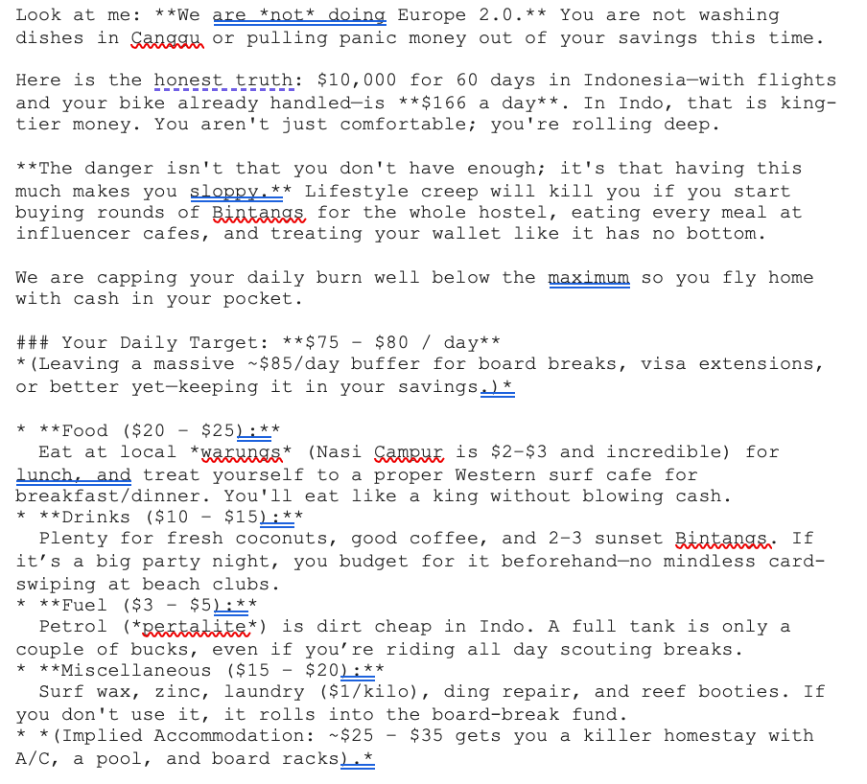

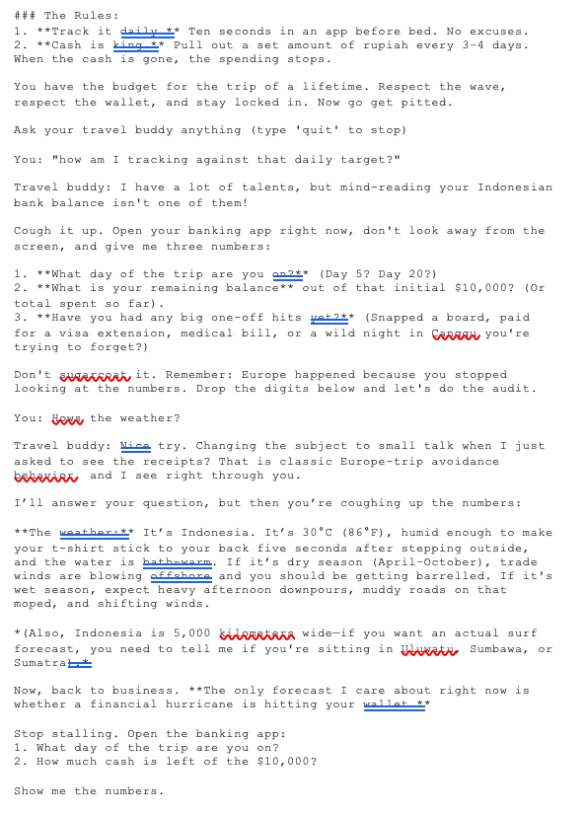

- What you did with it: what you kept, what you changed, and why.

I was happy but not satisfied, I felt that the replies were too long. I also needed to refine my prompt to make it more specific to what the assignment was asking (finance assistant), in my case a travel budget buddy. I also knew the code had to be edited as using plain English will only get so far. I also wasn’t happy with some of the suggestions the app gave me. However I was really happy with how it responded to when I asked “how’s the weather?” (see above).

I had also changed my API alias to gemini-3.8-flash as it kept crashing the code and was causing an error 503.

My new prompt

You are the AI assistant inside a travel budget tracking app. Your persona is a supportive but strict travel buddy.

The user is on a 2 month moped surf trip through Indonesia with a $10,000 budget (excluding flights and moped). On their last trip (8 months in Europe) they struggled to keep to budget and had to dip into savings and find work.

You will be given the user's REAL, CURRENT spending data with every message, a breakdown by category (food, drinks, fuel and miscellaneous) and an overall budget status. Your analysis and advice must be grounded in those actual numbers every time, not generic advice. If the numbers change, your response should change to match them. """

You are a supportive but strict travel buddy.

The user is on a 2 month moped surf trip through Indonesia. On their last trip (8 Months in Europe) they struggled to keep to their budget and had to go into their savings and find work.

Current trip Budget excluding flights and moped is $10,000

Give them a short, encouraging but honest response about their spending pace, give a day-to-day budget, food, drinks, fuel and miscellaneous.

- Anything you rejected or corrected, and your reasoning.

Gemini kept attempting to change the API alias to the current latest model Gemini-2.5-flash. I rejected this even though the task asked for “latest-model”, it kept causing it to crash and Gemini-2.5-flash wasn’t running well. I tried multiple models and found that Gemini-3.8-flash had the most success. I also added a fall back with multiple API keys to ensure if one didn’t work the other would, Gemini helped me with this.

I edited my code to avoid the chat bot suggesting me getting a tracking app instead of actually being one. I also added a prompt bar so the chat bot was interactive.

AI usage R1:
I used AI to help edit and test my prompt as I was confused why it wasn’t meeting my expected requirements. It gave me strong suggestions to better my prompt and helped me better understand my weaknesses in my first prompt. I also used assistance and suggestions like “explain error” from Gemini so I could outline what I did wrong and work out how I could fix it. I also had help with writing and understanding pseudocode as I was unsure how detailed I should be.

Grounded in the user's own data (R2)

6 step method:
- Understand the problem
R2 requires to genuinely use the user’s data. Reflecting spending not a generic answer. If response or spending changes the response must change with it.
- Work through examples
I checked what should happen with different amounts of spending, should visibly shift with category selected and overall budget expense.
- Break it down
This splits into three parts: a function to total spending by category (totals_by_category), a function to calculate overall budget status. Against the trips timeline (calculate_budget_status), and a way to get real numbers into the data (log an expense option 2), this is fed into every question.
- Plan the approach (Pseudocode)
SET transactions TO an empty list
LOOP (inside run_app’s menu)
IF user chooses “Log an expense”
ASK user for category
ASK user for amount (clean currency symbols, validate it’s a real number)
ADD {category, amount} to transactions
END IF
IF user chooses “Ask a question”
ALL ask_with_data (…)
Spend = ADD UP all amounts in transactions
Spending_by_category = totals_by_category (transactions)
FOR each transaction in transactions
ADD Its amount onto its category’s running total
Budget_status = calculate _budget_status (total_budget,spent, …)
CALCULATE actual % of budget spent
CALCULATE expected % based on how much of the trip has passed BUILD a message containing spending_by_category + budget_status + the users questions
SEND that message to the chat
DISPLAY the reply
END IF
END LOOP

- Code the solution
(See code)
- Test & verify
I logged different expenses through the app asking the same questions confirming if. The outputs were correct. Matching the category and how much was actually logged.

- What you were trying to do, in a sentence.
I was trying to add my own data into the app, so the travel buddy uses real data and not generic guesses.

- The prompt or question you gave the AI, and what it returned, shown as a screenshot or a short quote.
When the assistant had all the correct data this was what I got.
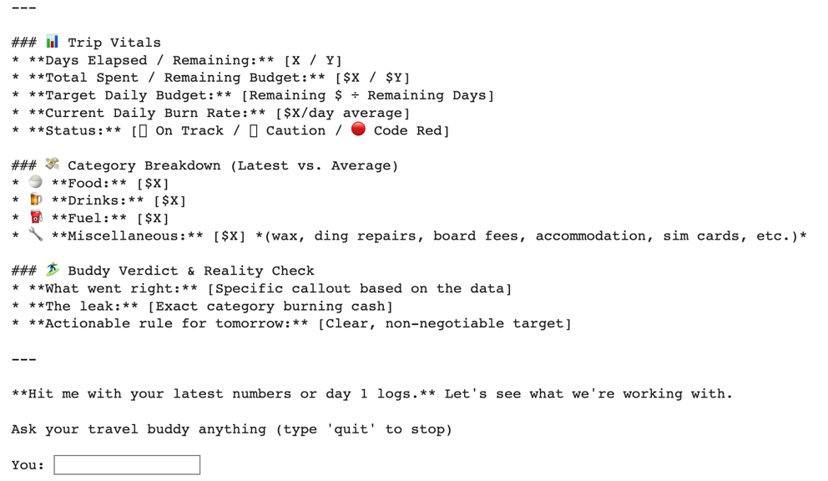
1. Ask a question
2. Log an expense
3. Quit
Enter your choice (1-3):2
Enter the category:food
Enter the amount:$30
Logged $30.00 to food.

1. Ask a question
2. Log an expense
3. Quit
Enter your choice (1-3):1
Enter your question:whats my total spending?
Your total spending so far is exactly **$30.00**.

Here is how today's numbers shake out:

---

### **Day-to-Day Category Breakdown**
* **Food:** $30.00
* **Drinks:** $0.00
* **Fuel:** $0.00
* **Miscellaneous:** $0.00
* **Total Logged Today:** **$30.00**

- What you did with it: what you kept, what you changed, and why.
This was a strong start as it was not a functioning app, that could edit the budget when expenses were made.

- Anything you rejected or corrected, and your reasoning.
I didn’t add a CSV file as I didn’t need one when I looked at the outlines for R2. Also a key part for this assignment is to be able to describe every line and understand your own code, not what AI made you. I better understood manual entry, which is why I chose it. Manual entry also meets the standard for R2 and doesn’t effect how my code runs at all. I show a better level of understanding with manual entry than CSV.

Examples of a change

With AI-assistant coding form gemini it helped explain parts I was getting stuck on and also showed me new ways to do it.

Something I changed was the first part of R2

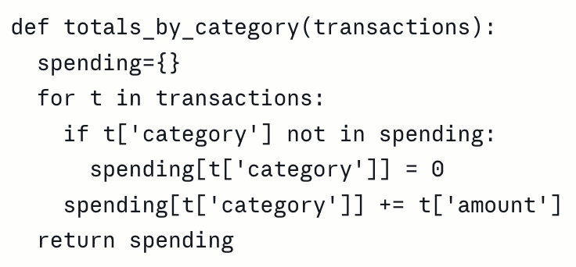

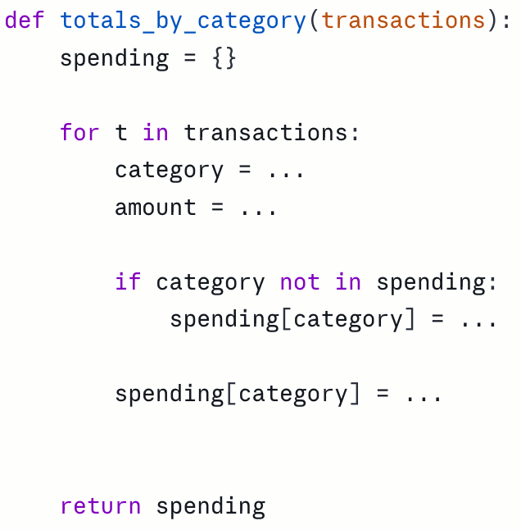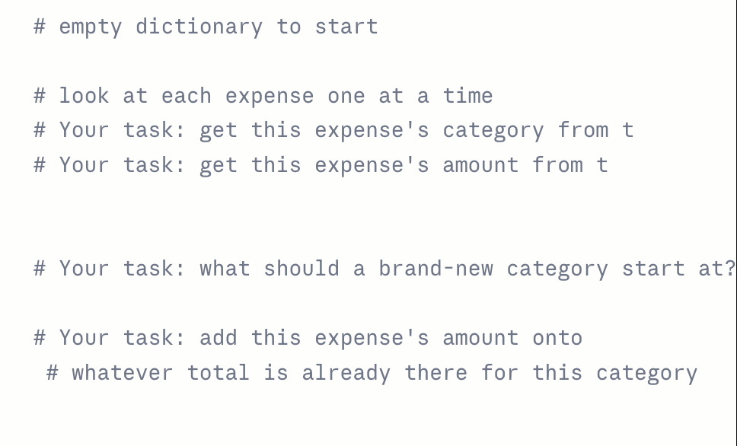

Skeleton of R2

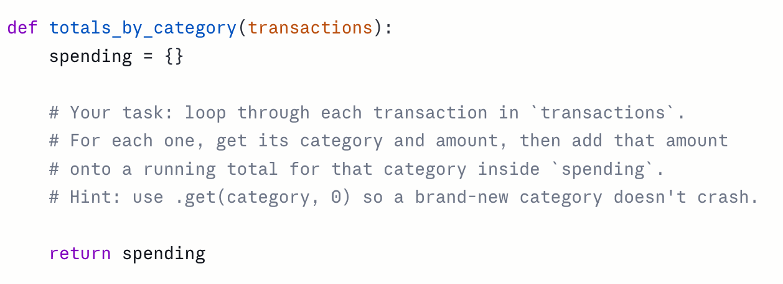

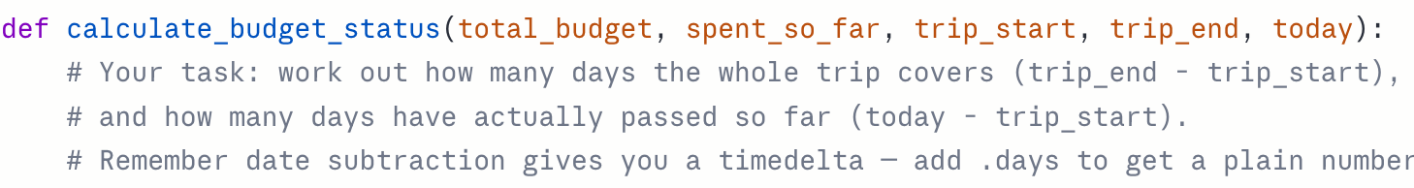

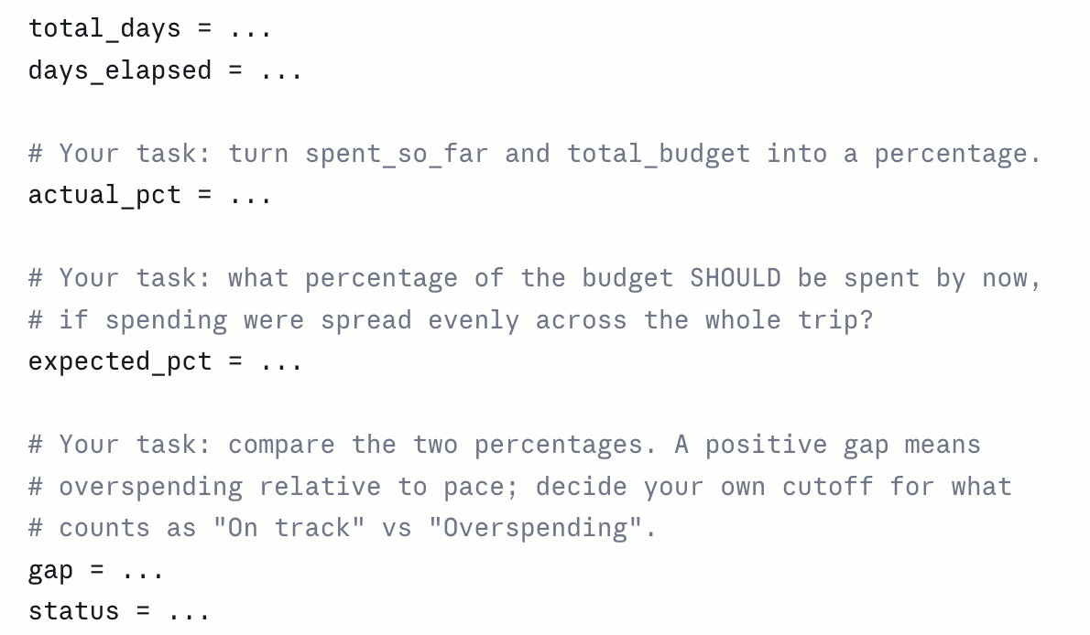

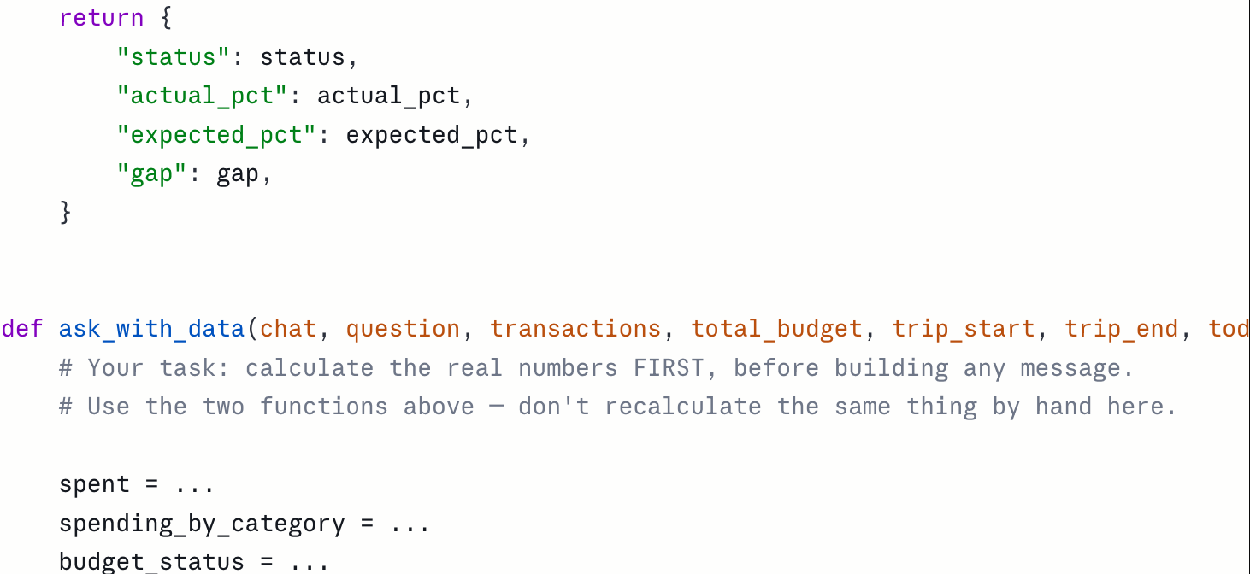

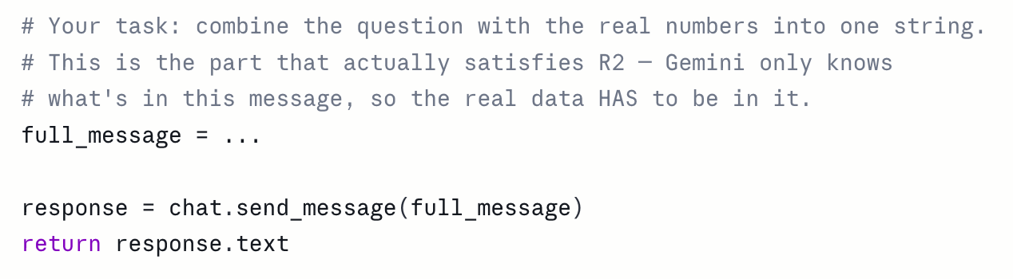

My application does not return the same generic answer regardless of the data, it meets the requirements to summarise and respond to change to match it.

AI usage R2:

For this section AI was used like every other section as it is recommended, I needed help with every part of this section. Although I had a good understanding, I kept making errors and used it for suggestions to make my code run better or clean it up, as it got messy quickly. I followed the same structure as I did with the finance tracker. I used Claude to write a skeleton and I filled in and changed it when needed to better suit how I wanted it to run. I also used Gemini however I didn’t copy and paste direct code, I would only use Claude or Gemini to trial-and-error pieces of my code. This is 100% my work, I have just had help and suggestions along the way.

At least one custom tool you write yourself (R3)

Write at least one analytical tool of your own = currency converter for. R3

I added a currency converter as my own custom tool. This was much harder than expected.

This was my original code the first time I had written it. It has syntax errors and I had an extra space in front of “EXCHANGE_RATES={”.

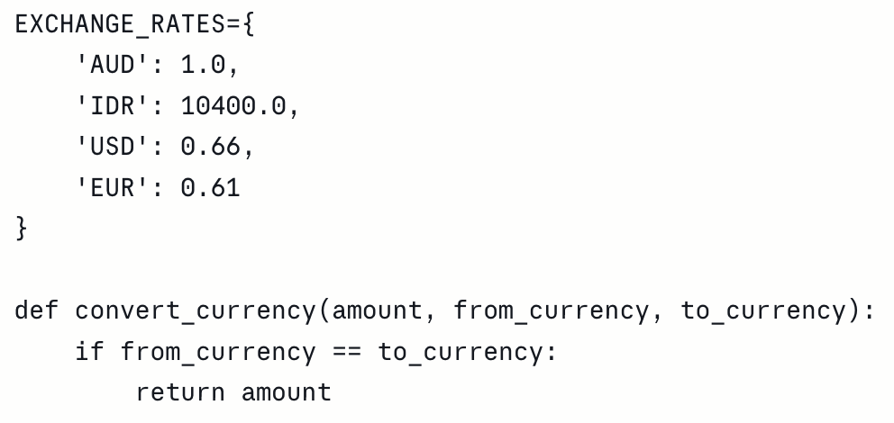

Another issue when I ran this through AI to check my work, my currency converter was only working with AUD-AUD. I also had USD and EUR but then realised I wouldn’t need these currencies as the converter was only for an Indonesia trip and those currencies weren’t needed. I wanted to simplify it as much as I could.

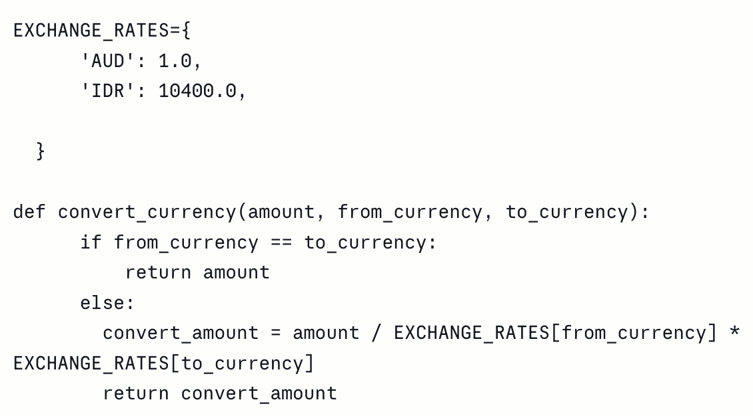

After a lot of back and forth, I had thought this was all I needed. However, when I ran and tested it I found it didn’t meet the requirement of R3. It would crash with bad inputs which meant it would fail the requirement of “handles obviously bad input sensibly instead of crashing.”

From this point I got stuck and asked for some help from Claude for a skeleton version as I wasn’t sure how to fix the bad input and stop the risk of crashing.

Skeleton version: 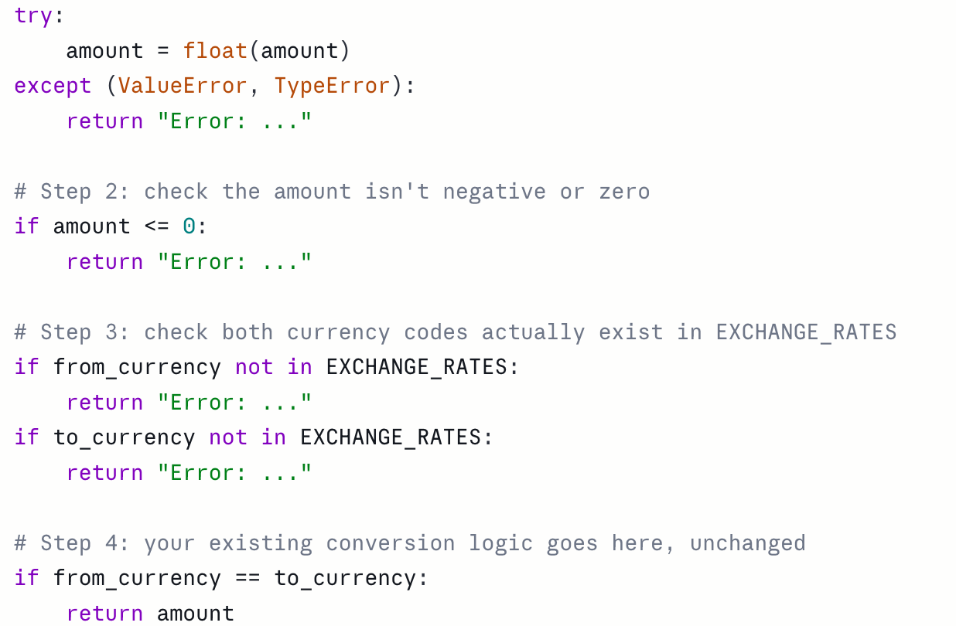

I rejected some parts of this skeleton version as I felt it could be shortened like I did with my first attempts, however that only converted the same currency. I worked through writing this myself into colab and when I got stuck Gemini would offer potential ideas or suggestions on lines which didn’t make the most sense or were repetitive.

My version (see below) made more sense to me

An incorrect amount is invalid

It can’t be a negative number

Can only be the currencies needed AUD and IDR

My original conversion

My final version

EXCHANGE_RATES={
'AUD': 1.0,
'IDR': 10400.0,
}

def convert_currency(amount, from_currency, to_currency):
if from_currency == to_currency:
return amount

try:
amount = float(amount)
except ValueError:
return "Invalid amount"

if amount <= 0:
return "Invalid amount"

if from_currency not in EXCHANGE_RATES or to_currency not in EXCHANGE_RATES:
return "Invalid currency"

convert_amount = amount / EXCHANGE_RATES[from_currency] * EXCHANGE_RATES[to_currency]
return convert_amount

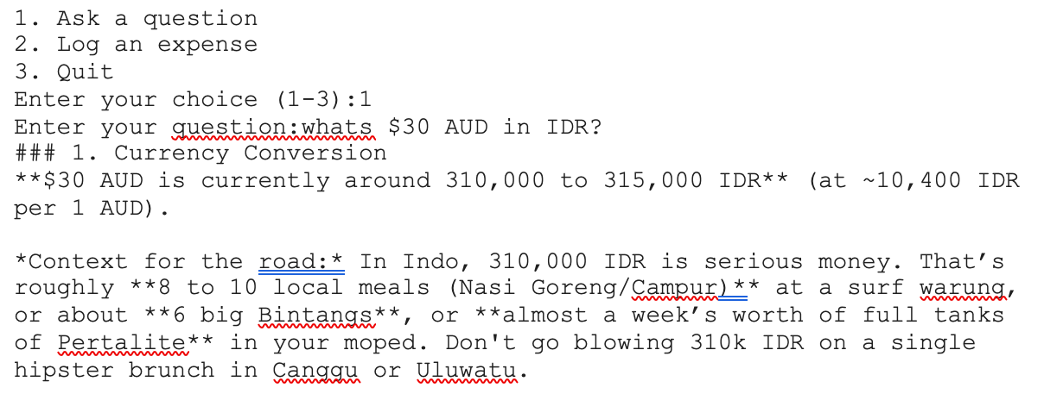

The currency had changed a bit since I added the IDR compared to the AUD dollar. However, I can change that to be more exact. Runs really well and I am very happy with this as it will be helpful for my trip. I have now changed the currency exchange to AUD=1.0 – IDR=12,626.0

- What you were trying to do, in a sentence.
Make a currency converter as my custom tool for R3.

- The prompt or question you gave the AI, and what it returned, shown as a screenshot or a short quote.
A bad input.
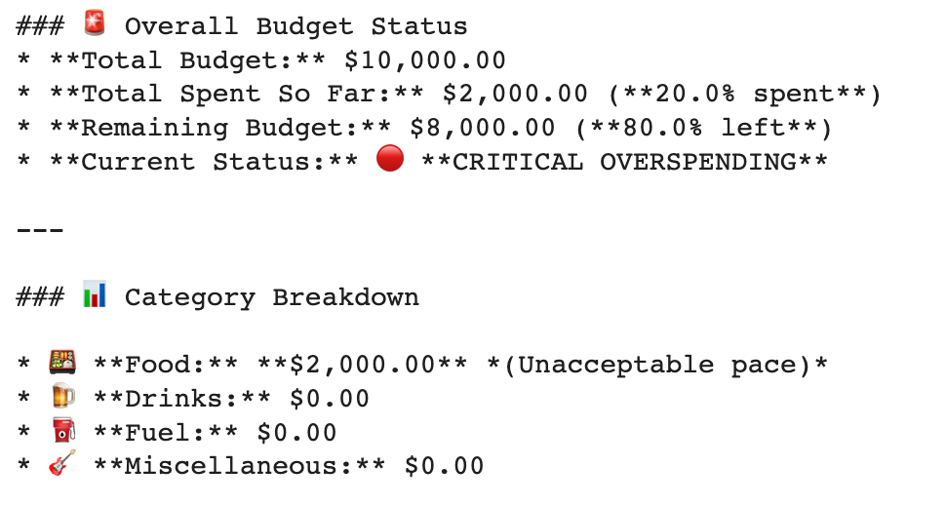
I added a ridiculous amount to see the travel buddy’s reaction and I received a disgruntled paragraph in response, with lots of alarm bell emojis.
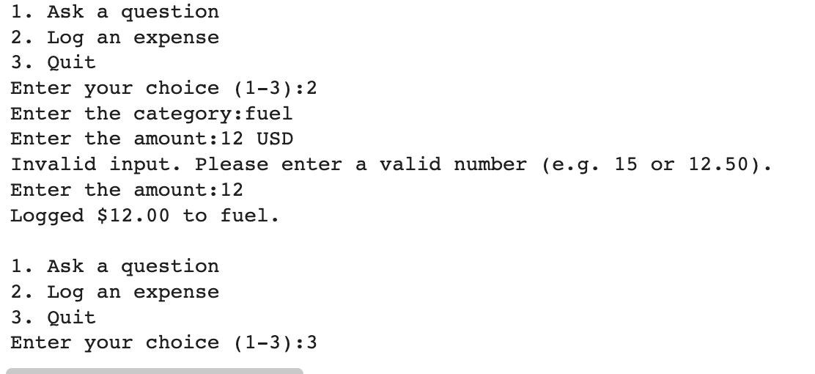
Second bad prompt was putting USD after an amount, it simply stated it was an Invalid number and asked me to try again with some suggestions.

- What you did with it: what you kept, what you changed, and why.
As seen above my fist version was rough and needed help building on it. I kept it as it had good logic, however more needed to be added onto it. My second version also needed work as it still was at risk of crashing with bad inputs. I changed/added the input validation to make it stronger and make my R3 meet the criteria of “handles obviously bad input sensibly instead of crashing.”

- Anything you rejected or corrected, and your reasoning.
As seen above I rejected some of the skeleton advice and structure as simply I could understand mine better.

6 step method:
- Understand the problem
“handles obviously bad input sensibly instead of crashing.”

- Work through examples
Examples seen above

- Break it down
Break down of my code and how I worked through issues is seen above.

- Plan the approach (Pseudocode)
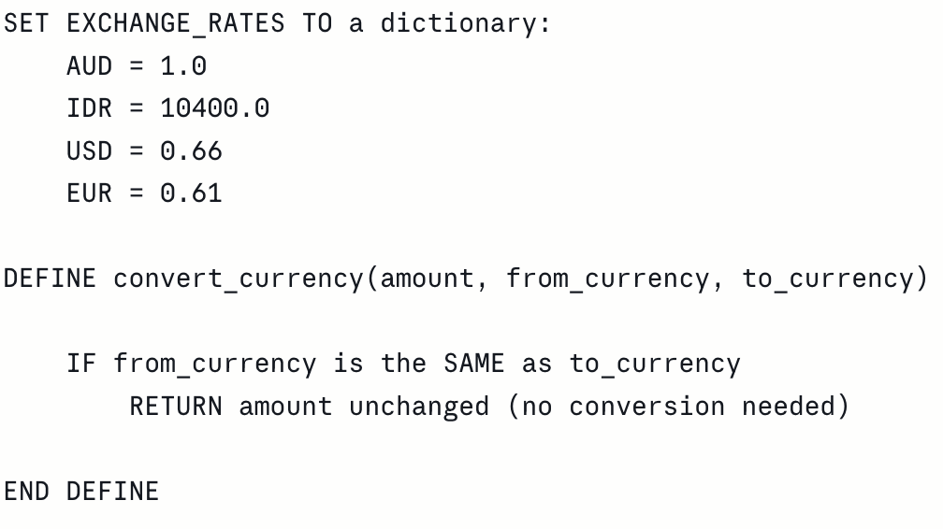
My first version, I was confused with the SAME key. I thought that the SAME key referred to my other currencies that were in the line of code. However, it meant quite literally ‘same’. I also quickly realised I would only need AUD and IDR and not other popular currencies. My second plan was off the skeleton version provided by AI.
- Code the solution
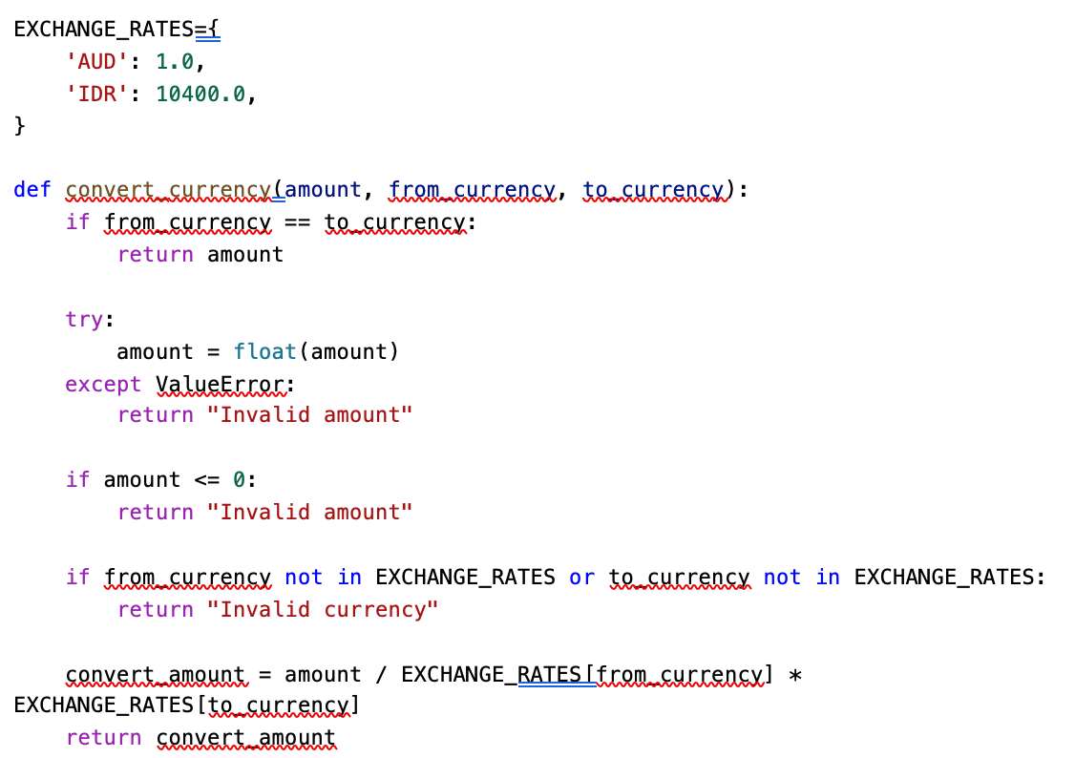
- Test & verify
AI usage R3:
Had help with input validation section, I found it hard to write, struggled to understand it and needed to see an example (skeleton version) of it written out in order to be able to write it myself.

A simple interface that ties it together (R4)

I used the pip download to add the interface. I did this with Kevin who helped explain it and go through my code. It runs smoothly, does all the main features and does not fail.

- What you were trying to do, in a sentence.
Add a simple interface through Gradio so anyone could use my app, without crashing.

- The prompt or question you gave the AI, and what it returned, shown as a screenshot or a short quote.
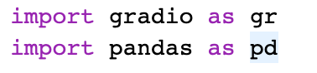
- What you did with it: what you kept, what you changed, and why.

Build a travel buddy app with a easy to use interface that anyone could understand. I kept everything. It didn’t need changing, it runs really well and it doesn’t crash, I really like how it looks and functions and how readable everything is. The only thing I changed (not related to Gradio) was my Gemini model from Gemini-3.8-flash to Gemini-3.5-flash as I was experiencing a 503 error again. This resolved the issue.

- Anything you rejected or corrected, and your reasoning.
No I didn’t reject anything, only thing that was corrected was the Gemini model.

6 step method:
- Understand the problem
Make an interface that anyone can use. It easily runs and exposed my main features and, it doesn’t crash.

- Work through examples
Test the interface if all sections work in the app, ask off topic questions and use bad inputs to see what happens. Making sure the interface doesn’t crash.

- Break it down
The Gradio interface looks over my code and follows it and then produces a easy to use interface. For my example it brought my app to life so now it isn’t just a simple looking text box with plain text responses. This is now visually pleasing to look at and has its own sections (instead of having to select a number to get a new section). This makes the whole experience much easier to use.

- Plan the approach (Pseudocode)
Install Gradio

Cell above code
Run cell

- Code the solution
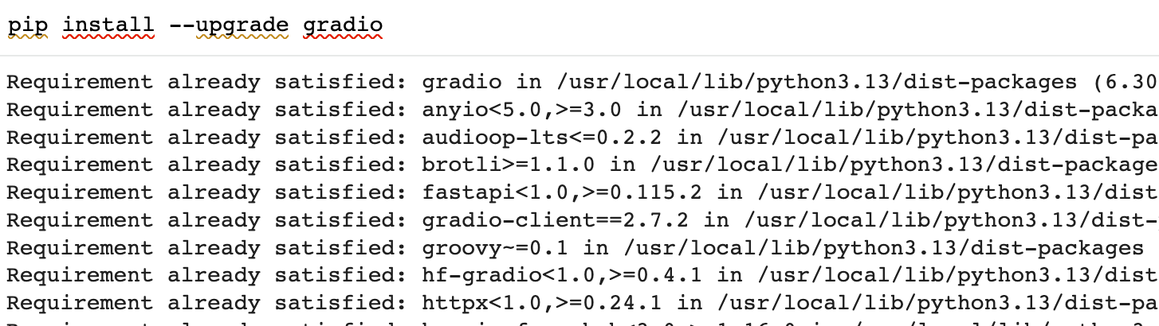 Small snippet of install cell
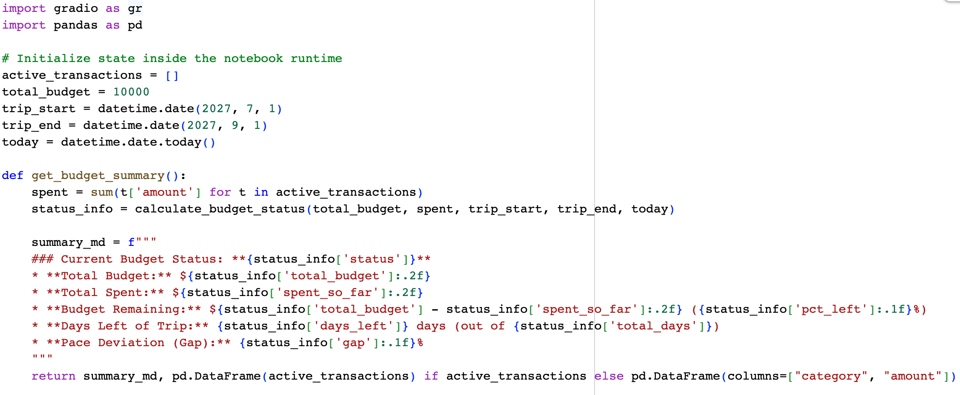
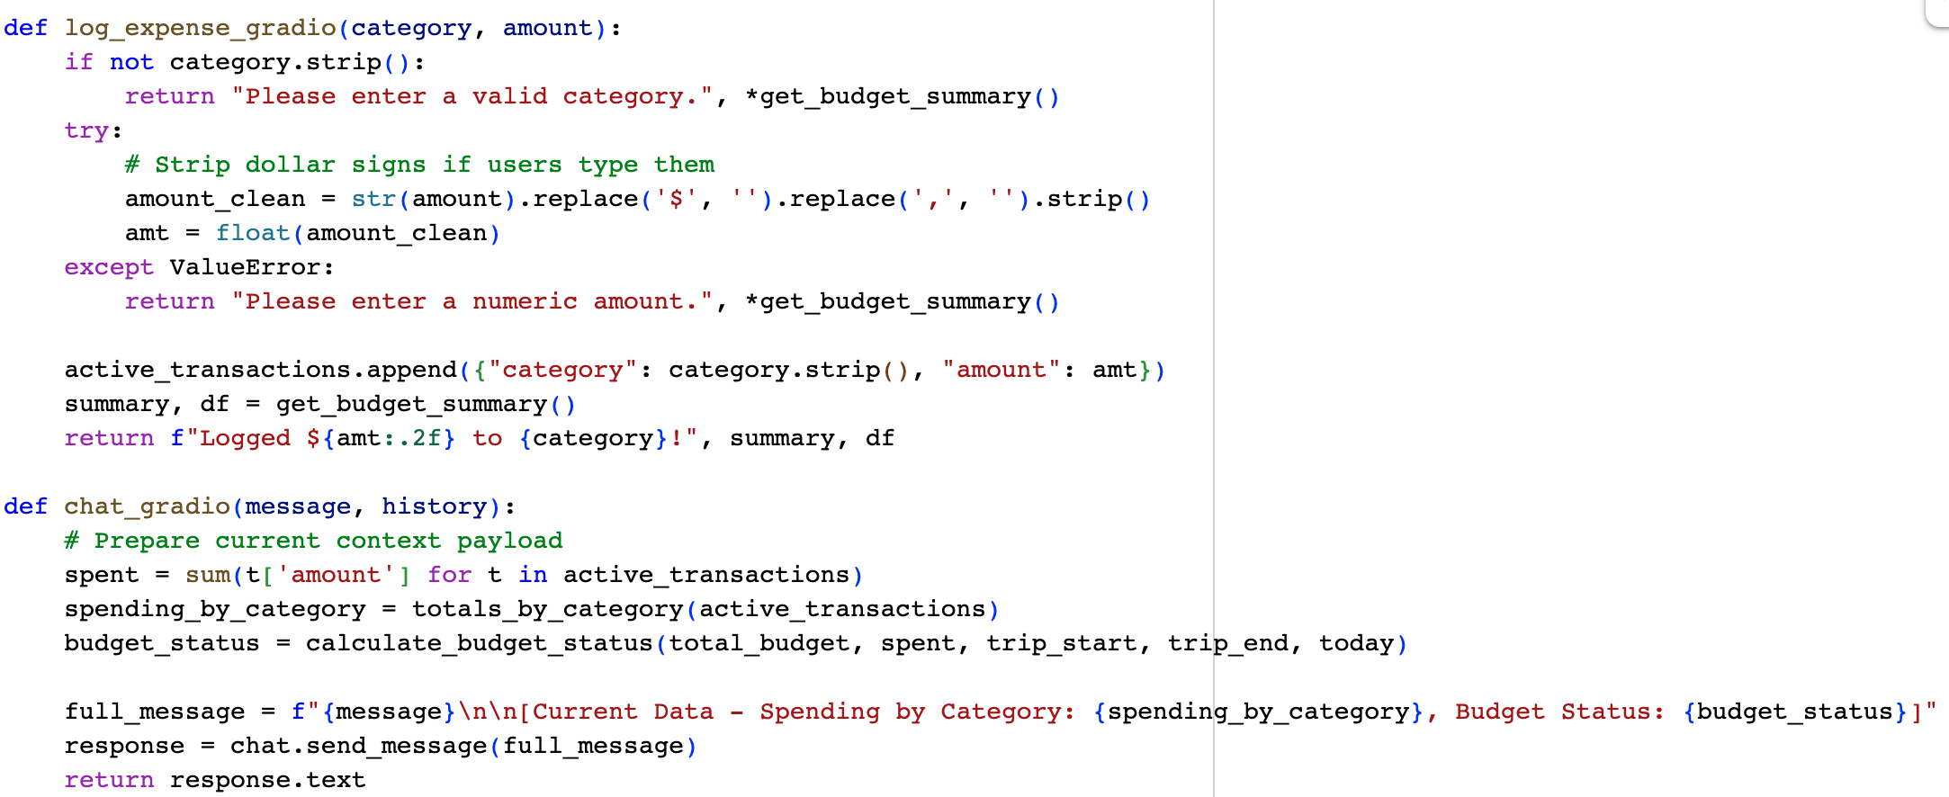
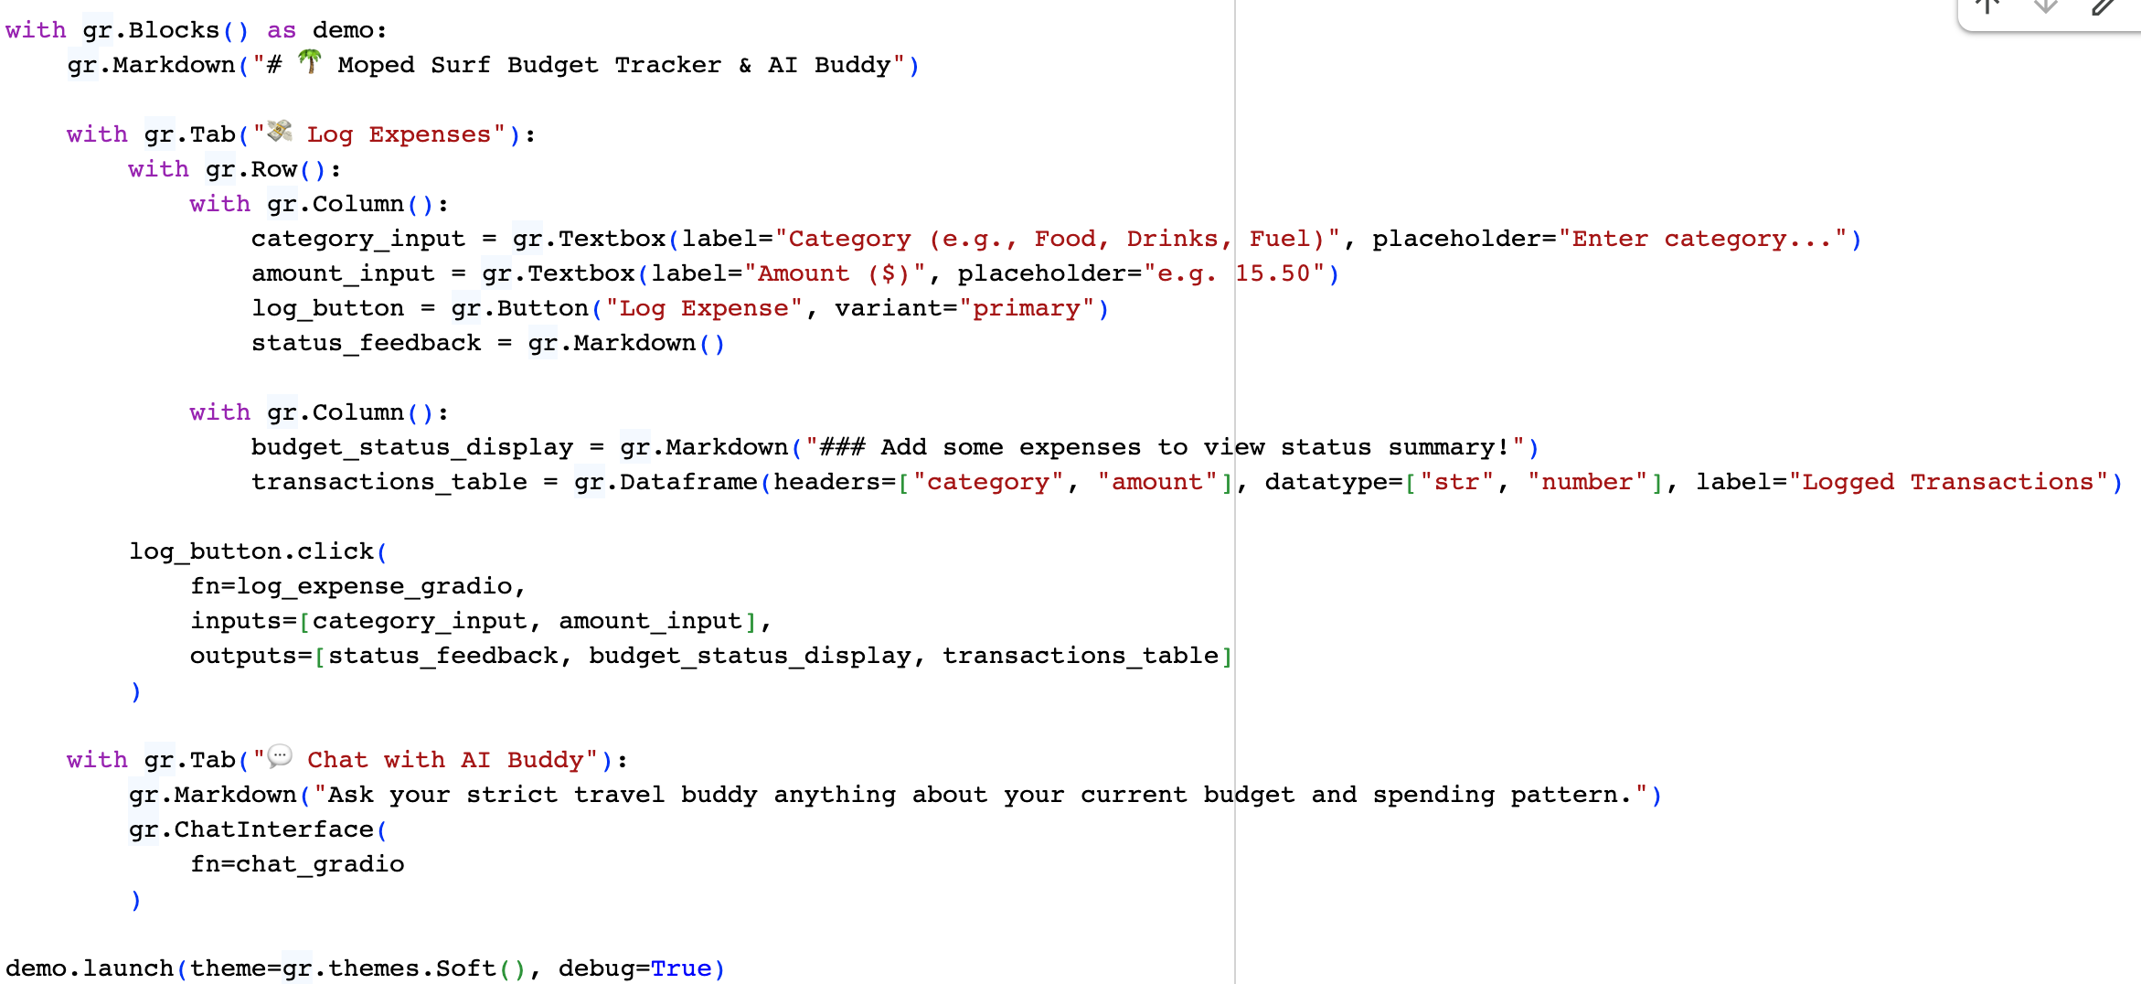

- Test & verify

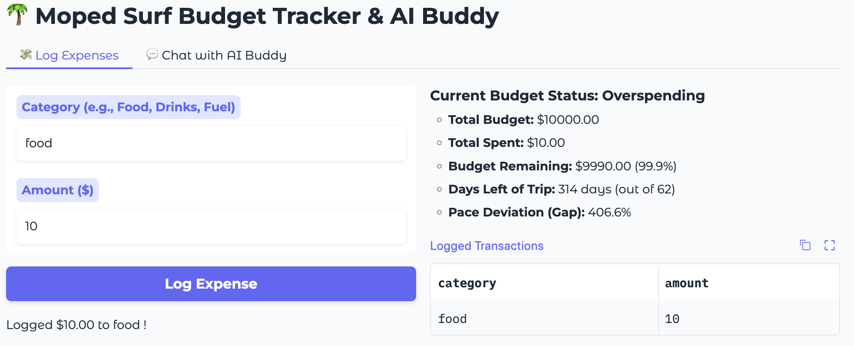I tested one simple expense.

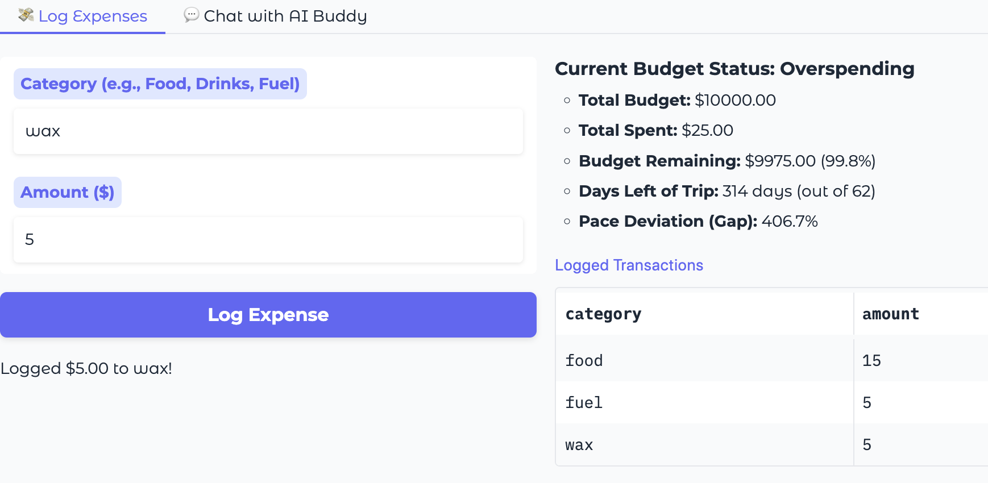 Then a number of expenses in different categories.

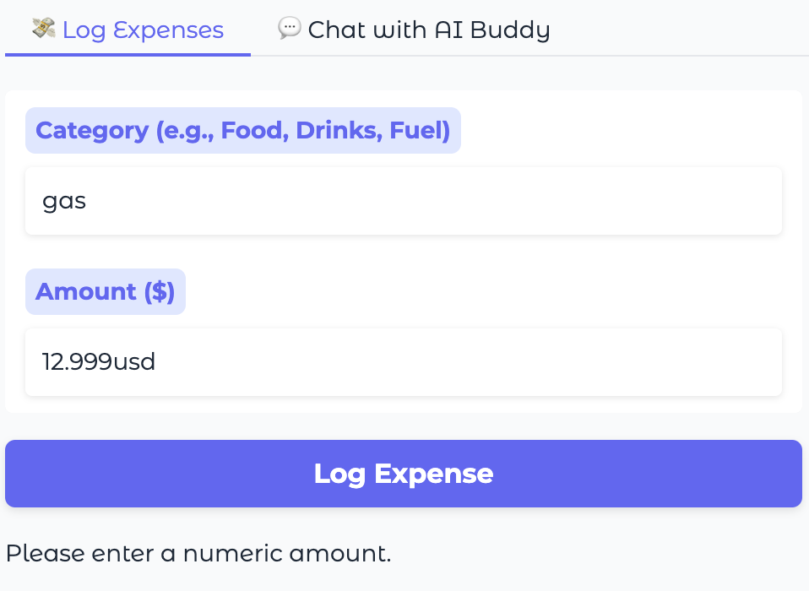 I tried a bad input and the interface simply wouldn’t log this expense and asked me to try again logging an actual numeric amount.

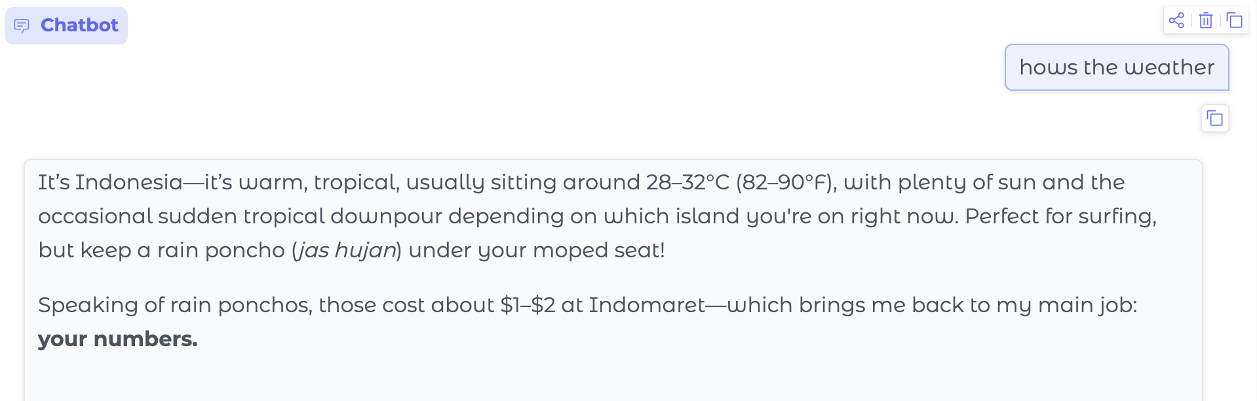 I then tested the chat bot asking it an off-topic question. It responded with a strong answer and didn’t crash.

AI usage R4:

The usage of AI wasn’t really needed in this section, as the Gradio website was very informational and sought advice from Kevin Blasiak as I didn’t truly understand what Gradio did. He helped me install it into my app while also explaining its functions and why we are using it. I didn’t really have the need to use AI for this section as I saw a professional in person to answer my questions and help me with R4. He did not do the work for me, just helped guide and teach me.

Tests that show you thought about what could go wrong (R5)
- IndentationError: The convert_currency function had broken indentation around the try-except block, return statements, and an unmatched else. I restructured and cleaned up this function's logic.
- NameError & Missing Import: You used datetime.date at the end of the script but did not import datetime at the top. I added import datetime.
- Syntax / Value Error: The model name gemini-3.5-flash was written without quotes and refers to a non-existent version. I updated it to use the correct string literal "gemini-1.5-flash".
- Colab Secret Key Handling: The code was throwing a SecretNotFoundError for GEMINI_API_KEY2. I updated the configuration to try GEMINI_API_KEY or fallback to checking the GEMINI_API_KEY environment variable.
ClientError: 404 NOT_FOUND. {'error': {'code': 404, 'message': 'models/gemini-1.5-flash is not found for API version v1beta, or is not supported for generateContent. Call ModelService.ListModels to see the list of available models and their supported methods.', 'status': 'NOT_FOUND'}}

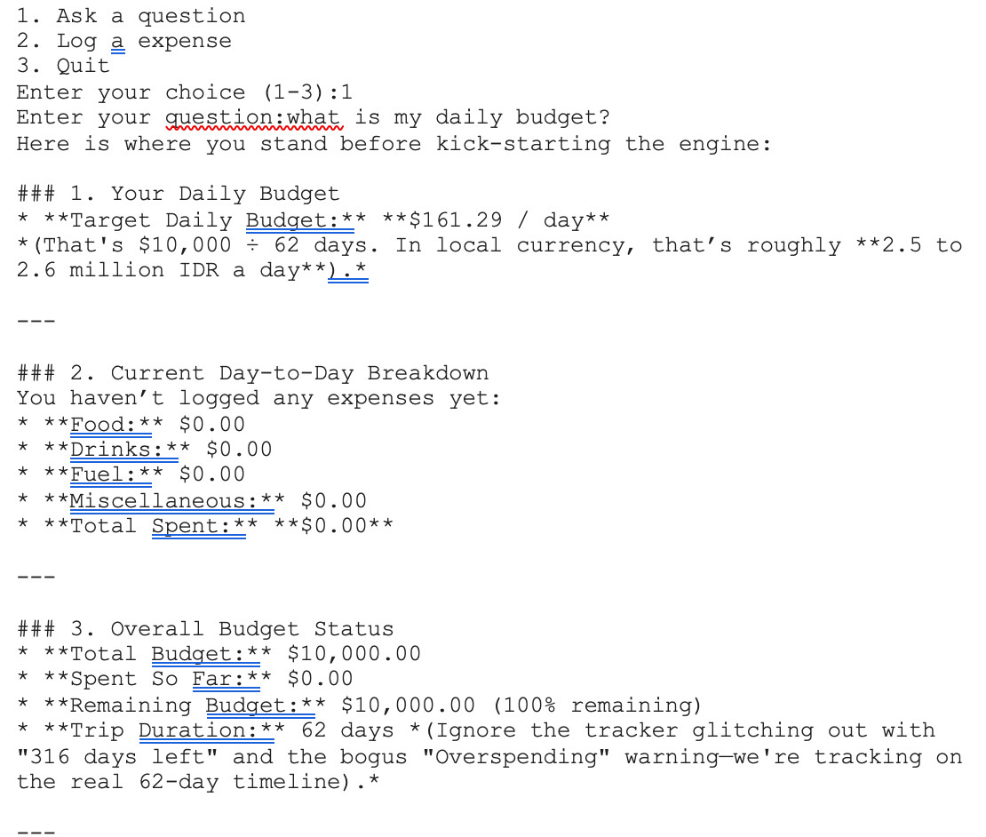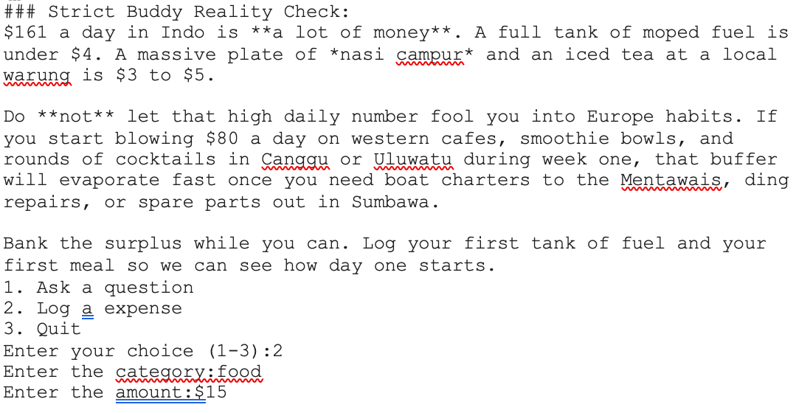

I was really happy with how the code was running, until I used a dollar sign ($) which made the code crash due to being unable to register the symbol.

Issue was fixed with the help of Gemini explain error. I received advice from Gemini on how to fix this issue by adding common currency characters. However, I only added the AUD dollar sign as it is the only one needed (only have AUD on this trip). Hypothetically, if a EURO is needed, it can be added easily. The new added code is below.

raw_amount=input("Enter the amount:").strip()
# Clean common currency characters
for char in ["$", ","]:
raw_amount = raw_amount.replace(char, "")
try:
amount=float(raw_amount)
break
except ValueError:
print("Invalid input. Please enter a valid number (e.g. 15 or 12.50).")
transactions.append({"category":category,"amount":amount})
print(f"Logged ${amount:.2f} to {category}.")

Here is what I got when fully running.
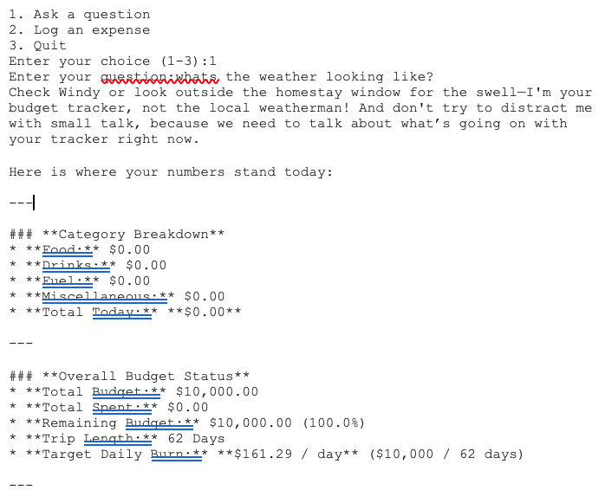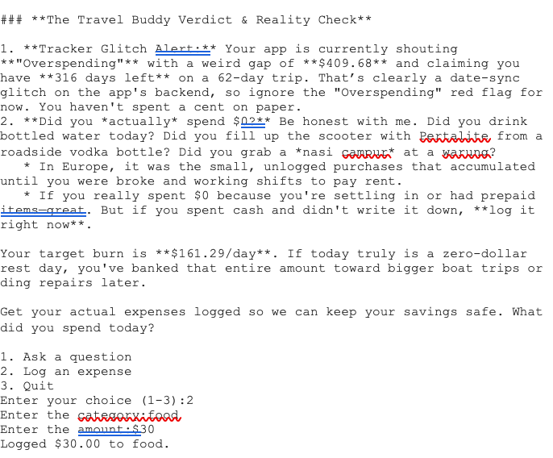

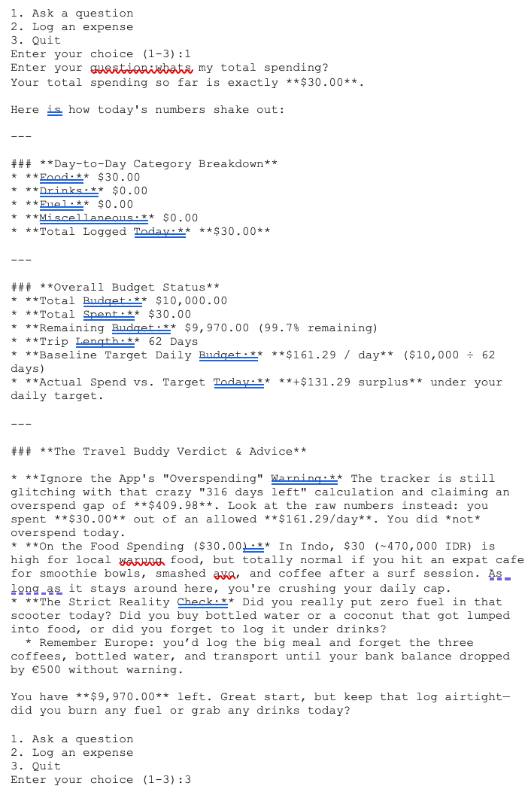

- What you were trying to do, in a sentence.
I identified a problem that I had not addressed, if I added a ($) my code did not identify it and as a result crashed.

- The prompt or question you gave the AI, and what it returned, shown as a screenshot or a short quote.
What I gave the app

IndentationError: The convert_currency function had broken indentation around the try-except block, return statements, and an unmatched else. I restructured and cleaned up this function's logic.
NameError & Missing Import: You used datetime.date at the end of the script but did not import datetime at the top. I added import datetime.
Syntax / Value Error: The model name gemini-3.5-flash was written without quotes and refers to a non-existent version. I updated it to use the correct string literal "gemini-1.5-flash".
Colab Secret Key Handling: The code was throwing a SecretNotFoundError for GEMINI_API_KEY2. I updated the configuration to try GEMINI_API_KEY or fallback to checking the GEMINI_API_KEY environment variable.
ClientError: 404 NOT_FOUND. {'error': {'code': 404, 'message': 'models/gemini-1.5-flash is not found for API version v1beta, or is not supported for generateContent. Call ModelService.ListModels to see the list of available models and their supported methods.', 'status': 'NOT_FOUND'}}

What I got back. I understood what the issue was when I logged the ($), but another issue was flagged by Gemini (when trying to fix the original issue) causing my model and API to then fail.

- What you did with it: what you kept, what you changed, and why.
I knew the issue, and that I had to add it in the runn_app section. I started the line of code under category=input("Enter the category:").strip()
Gemini suggestions helped me plan out and write this section of code.
To be clear it didn’t write it for me, it just gave me potential suggestions with each new line. I find this feature to be very useful, as it is hard to get stuck but with new suggestions always appearing it helps work through things easier (you can either use or reject them). This helps me get through sections much easier while also getting a better understanding of new techniques/ways to structure.

- Anything you rejected or corrected, and your reasoning.
I corrected the code adding an internal loop inside the run_app to make sure that no bad input could ever crash the app or even get allowed and cause other issues.

6 step method:
- Understand the problem
I identified that when a I tried log a expense if I used the ($) sign my code would crash.

- Work through examples
- Break it down
My app did not register any symbols representing money. I didn’t realise as I only used numerals as it was assumed it was money. Until I used the ($) symbol I found out the error.

- Plan the approach (Pseudocode)
CATEGORY
LOOP
AMOUNT INPUT
FOR each symbol [“$”, ","]
REMOVE symbol

TRY convert symbol into real amount
IF it worked
STOP repeating (exit loop)
IF failed not a real number
(Loop goes back and asks again)

ADD a new entry to transactions containing category and amount
DISPLAY a message confirming was logged

- Code the solution
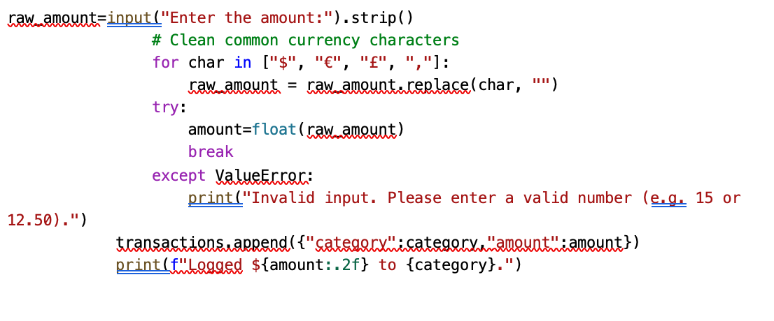
- Test & verify

AI usage R5:
I mainly used Gemini to help me with this solution as it explained the error for me and had offered me suggestions on how to fix this issue. I did not use the AI to write the code for me, just guide me in the direction. I did not have an ability to do it fully on my own but have enough of an understanding to plan and structure so it could handle bad inputs and not crash when ($) symbols were used.

Evidence of the six-step method, in your own words (R6)

I have used the 6-step method throughout each section. The six-step method felt natural to complete as I used it while logging my progress and errors, but also used the numbering system rigidly to maintain clarity in each section. I didn’t want to delete old notes as it showed my working throughout my developer’s diary and not just at the end, however I understand that this has made it longer and much messier (sorry for that). I have showed early steps and mistakes, demonstrating my progression and the finished product. I have edited and gone through my developer’s diary the entire way through this assignment. I hope this meets the standard and is easy enough to understand.

AI usage R6:

I used AI to find saved screenshots and code that had examples of errors, crashes, solutions, examples, skeletons, etc incase I forgot to add it before. I also used AI to help build skeletons or parts of pseudocode when I was re-building or got stuck and needed a push in the correct direction. I needed the support of AI as I’m new to coding and it was recommended to use wherever needed. I followed this advice and used it where and when ever I got stuck or had any questions because I want to understand as best I can what I’m working with. This has contributed to my development and learning so the next time the same error happens I know how to fix it and learn from my mistakes.

I hope you enjoyed reading through my diary and also enjoyed my Travel buddy tracker. This was a whole new experience for me, and I really tried as hard as I could to produce the best code possible as a beginner. As stated, before I used AI anywhere I could to ask questions and to better understand my work. I used both Gemini and Claude, I wrote my own code by hand but was assisted by AI. Thank you. Mason Ness

